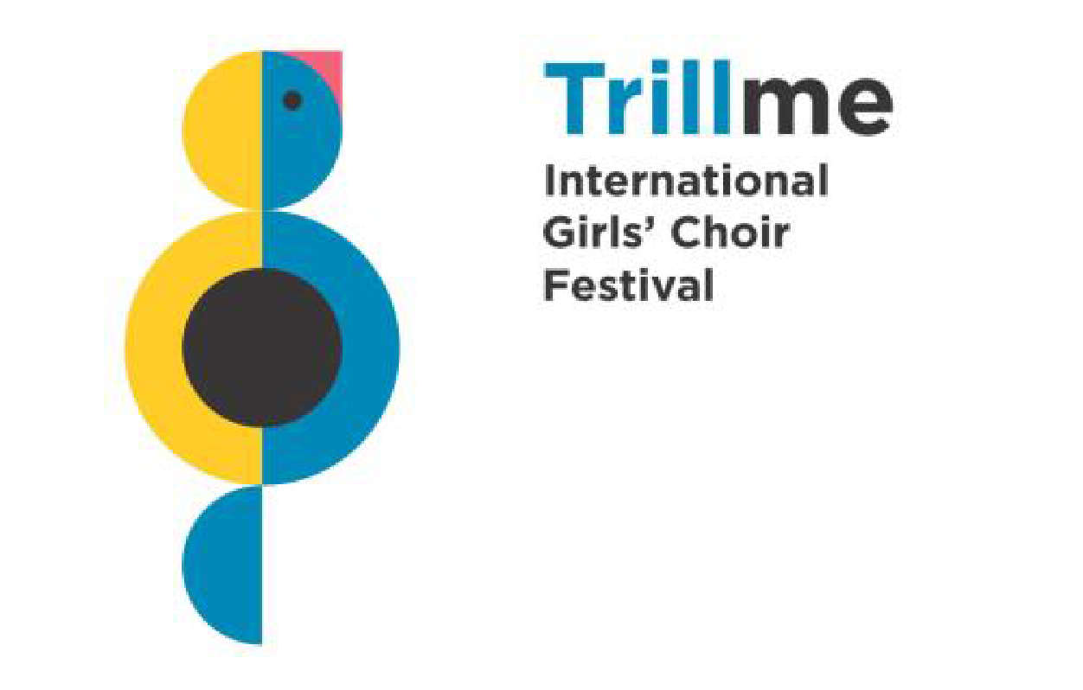

CH O I R P E R F O R M A N C E P R O G R A M M E

….................................................................................
name of choir
during Trillme Festival, 16th- 20rd September 2026

Thursday, 17th September 2026
Concert at one of Wielkopolska schools,
free programme, performance time: 35 minutes

Work  no. | Composer | Lyrics author | Title | Duration

Friday, 18th September 2026
Evening concert in Poznań,
free programme, performance time: 30 minutes

Work  no. | Composer | Lyrics author | Title | Duration

Saturday, 19th September 2026
Gala Concert at the Adam Mickiewicz University Hall in Poznań,
3 pieces, performance time: max. 12 minutes

Work  no. | Composer | Lyrics author | Title | Duration

…............................................ ….......................................................
place, date conductor

